Given the root of a Binary Search Tree (BST), return the minimum absolute difference between the values of any two different nodes in the tree.

Example 1:

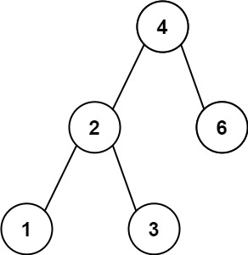

Input: root = [4,2,6,1,3]

Output: 1

Example 2:

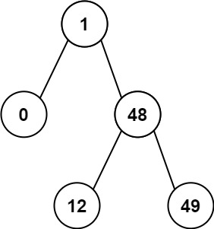

Input: root = [1,0,48,null,null,12,49]

Output: 1

class Solution {

public:

    int ans = INT_MAX;

    int pre;

    bool flag = false;

    void dfs(TreeNode* node)

    {

        if(!node)

            return;

        dfs(node->left);

        if(flag)

            ans = min(ans, node->val - pre);

        pre = node->val;

        flag = true;

        dfs(node->right);

    }

    int getMinimumDifference(TreeNode* root) {

        dfs(root);

        return ans;

    }

};

利用中序遍历的特性加上pre记录上一个节点的值进行更新ans，秒杀!